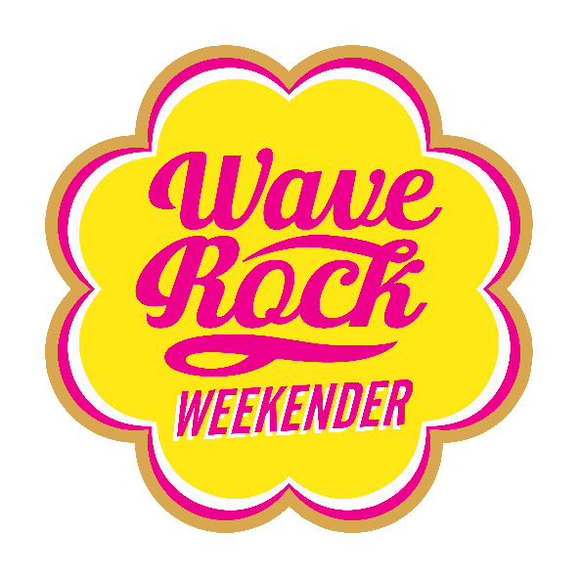

PICTURE OF A WAVE ROCK WEEKENDER LOGO IN PINK & YELLOW

Index:

General
Covid-19 safety measures
Getting to the show
Arriving & Camping
Gates
Camp Monitors
Key Points
Program
Other Offerings
Festival Shop
Food
Bar
Local Shops
Waste Management
Maps & Parking

GENERAL
The Wave Rock Weekender is a 70-hour long weekend music and film festival held near the Western Australian town of Hyden, 3.5 hours south east of Perth from 1pm Friday 24th September to 10am Monday 27th September, 2021.
The Monday is a public holiday in WA.

Hyden is the eastern-most town in the region, sitting between the wheat-belt and the Great Western Woodlands, not far from the rabbit proof fence. Wave Rock itself is a unique, 270 million year old wave shaped rock formation and
well known tourist attraction with a huge spirit that you can feel all weekend.

The show is a high quality, low capacity boutique event with a focus on the startling natural surroundings, great music and facilities, and minimisation of environmental impact. It takes place in and around the Wave Rock Caravan
Park and Resort and Amphitheatre ,3km north-east of Hyden, all around the Wave Rock precinct.

We will need to continue to run the two campsite format for 2021 and 2022 at least while COVID bubbles away but the local community and the Wave Rock team have come together to make many improvements to both sites.

Caravan Park Camp OG
will have a limited capacity and the set-up will be the same as the original Wave Rock (bar tent, original stage & food set-ups) and will run a secondary live & DJ music programme so it feels like home and you can enjoy a (slightly) earlier night if you need - or you can go wild at the Amphitheatre until very late if you wish. A fully serviced site but less intense site for OG’s who like it over there. There’ll still be projections & soundscapes on Wave Rock at night.
Amphitheatre Camp
the locals have done a bunch of work around the Amphitheatre improving power/water supply, walkways and we’ve added shade and extra facilities.
This site sits alongside the main arena/stage, main bar and food outlets and is a short walk from the salt pond and Lake Magic Sunset installation.
Salty & Delicious
The Salt Pond is full to the brim of fresh, delightful, super-floaty gypsum water and the eight gazebos do have a toilet and shower in each so we are pumping up the amenity and excitement in that Salty little village
BY DAY 9am-2pm
Frolic & Float in the Salt Pond, 3 x Masseuses (make a booking!), Refreshments, Pamper Station, Relaxation, Chai Café, Bananas in Cabanas games room
BY NIGHT 10pm-2am
Silent Disco “Miniscule of Sound”, Shisha Lounge, Chai Café, Mini Casino, Tarot, Micro Cinema, Popcorn & Fairy Floss, Projections, Hot Drinks, Blankies & Hot Water Bottles
We’ll also be projecting Wave Rock moments onto a huge screen at night over there so look out for our videographer if you want you 15 seconds of fame/shame
COVID BUSINESS!!
Although the event is set up to be able to operate in both phase 4 and 5 conditions - If we end up with capacity limitations due to any unforeseen COVID restrictions we will refund in order of purchase so as to meet any new capacity guidelines so we can run the show (eg if new limits capped us at 500 then first 500 ticket buyers can come!). If we are limited to the point where we have to cancel and the event is unworkable we will just refund you all

By making this trip, we know you all have the special thing that means you look for adventure rather than talk about it or wait for it. We are really glad you could make it and it is people like you who make this so personal and special for us too. Please respect the event and each other. It is really easy to be nice.
More pics and info available at: www.waverockweekender.com.au

COVID-19 Safety measures
- We will strongly advise patrons who display any symptoms of illness such; as dry cough, fever or tiredness to stay at home and seek medical advice.
- Temperature checks will be made available at the gate and first aid if you are unsure
- Hand sanitizer will be made freely available across the festival site, and we encourage you to use it as often as possible.
- Please listen to our friendly staff and follow signage when they offer social distancing advice.
- If you have any question or concerns relating to COVID-19 please feel free to approach any staff member, first aid or security member for support.

*DO NOT attend If you are waiting for a COVID test result.
*DO NOT attend if you have a dry cough, fever, sore throat or shortness of breath.
*DO NOT attend if you should be in quarantine or isolation.
*DO NOT risk attending if you have any doubts about your health.
Please reach out if you have any concerns or questions.
QR CODE check in on arrival
You can download the COVID safe app here: SafeWA (health.wa.gov.au)
We will have plenty of COVID safety measures in place this year to ensure everyone is well looked after and our event can proceed with the support or the government.
GETTING TO THE SHOW
DRIVING
If you’re driving yourself to the show, allow four hours for the trip and use the map provided with this info.
DISTANCE
340km from Perth CBD
DURATION
Up to 4 hrs each way. Decent road, 110km/hr speed limit most of the way. Some bits narrow close to Hyden.
ROUTE
A map is provided with this info showing the route from Perth.
From Perth take Albany Hwy to the Brookton Hwy which begins at Armadale.
Continue through Brookton, Corrigin, Kondinin and Kalgarin to Hyden.
The custard tarts at Stumpys roadhouse in Brookton are strangely delicious.
The route is signposted; follow signs to each town listed above.
FUEL
Fuel is available in Brookton, Corrigin, Kondinin and Hyden.
Availability is limited late at night. Corrigin Roadhouse is open 6am to 9pm daily.
Hyden Roadhouse is open 7am to 9pm daily.
NOTES
Last non-Telstra mobile coverage used to end in Corrigin, who knows where it will end this
Year. Expect freedom from your phone if you are not on Telstra. Patchy freedom if you are.

WELCOME TO COUNTRY
Everyone is invited to attend the Welcome to Country being conducted by Noongar elders
from the Collard family, including a smoking ceremony, between 10.30am and 11.00am Saturday 25 September around the main stage, and meet the Collards afterwards.

ARRIVING & CAMPING
----NOTE THE NEW WAY IN!!----
--USE THE SITE MAP TO HELP YOU FIND YOUR WAY--

OG CAMP A – All Coloured camps
Yellow, Green, Purple, Blue, Red, Orange, Black
When you arrive into Hyden continue along Hyden-Lake King Road.
Keep going on E Hyden Bin Road past the usual Lovering Rd/Wave Rock turn off
(No access to check in via Lovering Rd this year)
Turn left at Wave Rock Rd – it will have a big sign and is a gravel road, drive about 1km down that road you have arrived at Camp A Checkpoint 1 for processing.
Have your tickets ready and you will be greeted by gate staff who will direct you where to go from here

AMPHITHEATRE CAMP B – All Astronomy camps & Artists & Glamping
Lil Dipper, Big Dipper, Galaxy, Milky Way, Three Sisters, Saucepan, Artists, Glamping
When you arrive into Hyden continue along Hyden-Lake King Road.
Keep going on E Hyden Bin Road past the usual Lovering Rd/Wave Rock turn off
(No access to check in via Lovering Rd this year)
Keep going on E Hyden Bin Road (past Wave Rock Road turn-off)
Turn left at the entry to Wave Rock Resort
It will have a big sign and is a gravel road with a limestone wall at the entry.
About 1km down that road you have arrived at Camp B Checkpoint for processing.
Have your tickets ready and you will be greeted by gate staff who will direct you where to go from here

.

GATES
FRIDAY GATE - 1PM to 8PM
SATURDAY GATE - 11AM to 6PM

- Gates will be operating from Friday 1PM-8PM and Saturday 11AM-6PM
- When you arrive at your camp you will see a checkpoint at which you’ll pull over to have your tickets collected and receive your wristbands.
- Your wristband will allow you access to move freely between both campsites.
- You’ll be directed to the supervised gear drop point where you’ll leave your stuff to be looked after whilst you park your car AWESOMELY, CONSIDERATELY and AS DIRECTED
- All camping is located at Camp B (Amphitheatre Camp) there is a shuttle bus service to take any back to Camp A. Or you can walk back and take in the scenery along the way
- PLEASE NO BYO it contravenes our licence, jeopardises the show and risks fines for staff and suppliers
Security/camp staff will be doing bag checks at gear drop and keeping an eye out all weekend.
If you choose to take booze out of your car at gear drops be aware it will be politely but ruthlessly confiscated
Nice people from your camp will help you find your campground and your camp monitors will show you where to camp so you can keep distance and be safe.
Once you’ve set up your tent you are free to have the best time ever.
- Welcome to Country happens Saturday.

Camp A & Camp B Weekender Pass - 3 Nights (FRI/SAT/SUN)
Weekender Pass includes a camp site suitable for a small tent inc
access to showers, toilets, facilities in both camps as you please.

Camp A also has some access to power & cooking facilities.

This event is 18+ only / Fully licensed event (No BYO) / No children or fur babies / This is a tent camping festival, no campervans or caravans

We have to look for and confiscate BYO booze.
Don’t lie to the nice staff, leave it in your car!

CAMP MONITORS
Camp monitors are wise vibe masters who are appointed to assist you in your quest for a good time.
They know stuff and they have access to tools.
Talk to your camp monitor, if you need to move sites to be with friends, they can help you arrange this.

Camping Manager - Camp A & B Wade Halls
Camping Manager - Camp A & B Beck Drew
Camp A - 2IC / Camp liaison Kombi
Camp A - Camp Director /Monitor Joel Camp Woody
Camp A - Blue Camp Monitor Jess
Camp A - Green Camp Monitor Edward
Camp A - Green Camp Monitor Roxy
Camp A - Purple Camp A Monitor Yali
Camp A - Yellow Camp Monitor Rin
Camp A - Yellow Camp Monitor Eziah
Camp A - Purple Camp A Monitor Poppy
Camp A- Orange Camp monitor Ella
Camp A- Orange Camp monitor Roisin
Camp B – 2IC / Camp liaison Kon
Camp B – Monitor Jessica
Camp B – Monitor Megan
Camp B – Monitor Zak
Camp B – Monitor Bryn
Camp B – Monitor Tracey
Camp B – Monitor Kahlia
Camp B – Monitor Laura
Camp B – Monitor Biba
Carer of the Rock /rock cleaner Georgia

Once you’ve set up your tent you are free to have the best time ever.

KEY POINTS
- Your mobile phone might not work past Corrigin. You will be free. There will be blackboards around so you can write messages to each other. You’ll be surprised how fun it is to find others without a phone.
- If you need anything, ask at the Festival Shop next to the amphitheatre bar, or talk to your camp monitors. Information, supplies, or help: just let us know.
- Be good to each other and the environment. See waste management information below. Bar cups are compostable (use green bins), not plastic. You'll notice extra hygiene measures and space at all service locations.

Festival Shop
FRI 6-11PM, SAT + SUN 9AM TO 11PM

Located Inside the Amphitheatre Bar Building
Merchandise | Salt & Sugary Snacks |Information | Lost Property |Useful things

Merchandise
Festival stubbie holder$10
Festival hoody/jumper $80
Festival Tee $40
Bucket hat $20

Free Stuff
Total Respect
Aerogard Spray/Bush Perfume
Berocca
Hydralyte
Condoms
Tampons
Water

$2.50 Stuff
Sweet Things
Chupa Chups
Eclipse Chewy Mints
Chocolate Bars

Useful Things
Tally Ho Cigarette Papers 50’s
Ventti Blue Super Slim Filters 140’s
Toothbrush
Batteries
Heavy Duty Tent Pegs

$5 Stuff
Sweet Things
Natural Confectionary Company Party Mix 240g
Natural Confectionary Company Snakes 260g
Salty & Delicious
Smiths Thinly Cut Sea Salt 175g
Cobs Cheese Puffs 120g
Cobs Sweet n Salty Popcorn 120g
Grainwaves Sour Cream 175g

Useful Things
Lip Balm
RID insect Repellent/sunscreen Combo 100ml
Torches

Food

AMPHITHEATRE

BOX PIZZA
OPENING TIMES
Friday: 2pm 12am
Saturday: 7am – 12am
Sunday: 7am – 12am
Sunday: 7am – 12am
Monday: 7am – 10 /11am

MENU
Pizza by the slice $6 ea served with rocket
Margherita w bocconcini, tomato, basil
Taylor Swift w mushroom, red onion, kale, shaved Parmesan
Popeye- 3 greens (kale, spinach, silver beet), shaved Parmesan, feta, leek
Patata- potato, capers
Massive Attack w chorizo, salchichón, artichokes, red onion
Fassbender w double smoked ham, provolone artichoke, red onion

COFFEE SHACK
OPENING TIMES
Friday: 2pm – 10pm
Saturday: 7am – 9pm
Sunday: 7am – 9pm
Monday: 7am – 10 /11am

MENU
10oz Coffee $4.5
Decaf, extra shots + .50c
Almond and Soy milk +$1
Batch Brew $4.5
Hot Chocolates $4
Matcha Latte $4
Tumeric Latte $4
Tea $3
English Breakfast
Earl Grey
Peppermint
Green

DOMENICO'S CONTINENTAL DELI & PASTA KITCHEN
OPENING HOURS
Friday: 2pm – late
Saturday: 8am – late
Sunday: 8am – late
Monday: 8am – 10 /11am

MENU
Drink Range
San Pellegrino range in cans (limonata, aranciata, natural) $5
Espresso only (no milks) in small espresso cups $3
Day Menu 8am-5pm
Continental Rolls
House Special – mixed meats/cheese/pickles in a crusty roll $12
House Special (Vegetarian) – marinated mushrooms/cheese/pickles in a crusty roll $12
Hot Rolls
- Breakfast Roll (scrambled egg/bacon/mushroom) $12 (until sold out)
- Meatball roll (italian meatballs/napoli sauce/cheese) $12
- Chicken Schnitzel roll (schnitzel/lettuce/dressing) $12
Arancini & Chips $12
Chips $6

Night Menu 5pm-late
Fresh Pasta served from 5pm
Big bowl of hot pasta served with crusty bread
Bolognese Pasta $15
Pumpkin & Kale Pasta (vegan) $15
options; add parmesan, chilli oil, pepper
Hot Rolls
- Breakfast Roll (scrambled egg/bacon/mushroom) $12 (until sold out)
- Meatball roll (italian meatballs/napoli sauce/cheese) $12
- Chicken Schnitzel roll (schnitzel/lettuce/dressing) $12
Arancini & Chips $12
Chips $6

LA PALETA
MENU
Paleta's $5
100% Mango
Watermelon
Raspberry lemonade
Cucumber lime
Salted caramel
Chocolate
Mango coconut

MR. GOZ
OPENING HOURS
Friday: 2pm 12am
Saturday: 7am – 12am
Sunday: 7am – 12am
Monday: 7am – 10 /11am

MENU
Gozleme $15
Gourmet chicken
Spicy beef
Pepperoni
Potato
Vegetarian

LUSTY’S BURGERS by Soul Cocina
OPENING HOURS
Friday: 2pm 1am
Saturday: 11am – 1am
Sunday: 11am – 1am
Monday: 7am – 10 /11am

MENU
Breakfast @ Soul Cocina
Got Lucky burger - Toasted bun with Sweet corn & jalapeño fritter, fried egg, bandito relish & rocket $16
Lunch/ Dinner
All served with seasoned fries for $20
El Toro Burger – Smoked pulled beef brisket, chimichurri, cheddar, caramelized red onion
Chikalika Burger – Crispy Fried Chicken, guacamole, jalapeno aioli, slaw
Jungle Burger – Red bean & peanut burger, chilli corn relish, mesclun

SOUL COCINA
OPENING HOURS
Friday: 2pm 11pm
Saturday: 7am – 11pm
Sunday: 7am – 11pm
Monday: 7am – 10 /11am

MENU
Breakfast 8 - 10:30
Huevos Rancheros $16 gf, vegan option
Free range eggs, beans, guacamole, salsa, rocket, chimichurri,corn tortillas & pulled pork (optional)
Got Lucky burger $16
Toasted bun with Sweet corn & jalapeño fritter, fried egg, bandito relish & rocket

Lunch/ Dinner
Taco’s $10 each or 2 for $18
Fresh corn tortillas, Mexican slaw, fresh salsas & sauces
- Beer Battered Fish (Augusta Bronzie), pickled red onion
- Slow Cooked Pulled Pork, chilli con queso, pico de Gallo salsa GF
- Smoky Black Bean, cucumber fennel mint salsa V GF
Chimichanga $18
Deep fried pulled beef & chipotle rice burrito with soul destroying chilli sauce, sour cream, salsa & Fries
Cuban Fried Chicken $18
Buttermilk crumbed breast, zesty salad, lime aioli, fries
Sunshine Bowl $16
Vegan bowl of garden delights, coconut black rice, beans, pumpkin, salsas, guacamole & chimichurri GF V
Tijuana Fries $13
Seasoned Fries with parmesan cheese, chipotle crema & lime GF
Rosarita Fries $15
Seasoned Fries with chilli con queso (warm cheese sauce), pico de Gallo salsa GF
Load with pulled pork + $2
Plain Fries $10

CARAVAN PARK

CLEAN TASTY DIRTY
OPENING HOURS
Friday: 2pm 10pm
Saturday: 7am – 9pm
Sunday: 7am – 9pm
Monday: 7am – 10 /11am

MENU
Quesadillas $12
Vegan Extravaganza - Avocado, sauerkraut, spinach, hummus and vegan mayo
The Fun Guy (fungi) - Mushroom, cheese, fetta, spinach, tomato, red onion and a dash truffle mayo
Spicy Cheeseburger - Pulled beef, mustard, pickles and cheese
Pork 'N' Slaw - BBQ pulled pork, red cabbage, carrot, corn, cheese with a drizzle of chipotle mayo

COCO'S KITCHEN
OPENING HOURS
Friday: 2pm 10pm
Saturday: 7am – 9pm
Sunday: 7am – 9pm
Monday: 7am – 10 /11am

MENU
Fried Rice (Egg, Bacon, Vegetable) $14
Fried Noodles (Egg, Chicken, Vegetable) $14
Honey Chicken $14
Sweet Sour Pork with Sauce $14
Vegetable Omelet $14
Above combination $14
Fried Chicken Wings $3ea
Spring Roll $2ea 4 for $6
Curry Puff $2ea 4 for $6
Soft Drink $3

COFFEE SHACK
OPENING TIMES
Friday: 2pm 10pm
Saturday: 7am – 9pm
Sunday: 7am – 9pm
Monday: 7am – 10 /11am

MENU
10oz Coffee $4.5
Decaf, extra shots + .50c
Almond and Soy milk +$1
Batch Brew $4.5
Hot Chocolates $4
Matcha Latte $4
Tumeric Latte $4
Tea $3
English Breakfast
Earl Grey
Peppermint
Green

DAL’S PIZZAIOLO
OPENING HOURS
Friday: 2pm 10pm
Saturday: 7am – 9pm
Sunday: 7am – 9pm
Monday: 7am – 10 /11am

MENU
Margherita - Mozzarella cheese, Tomato and Basil
Romana - Tomato, cheese and Mild Italian Sausage
Vegetarian - Tomato, cheese and Chef's choice of Veggies
Hawaiian - Tomato, cheese, ham and pineapple
Siciliana - Tomato, cheese, Chef's choice of Vegies and Mild Italian Sausage

LATINA PLANT POWER
OPENING HOURS
Friday: 2pm 10pm
Saturday: 7am – 9pm
Sunday: 7am – 9pm
Monday: 7am – 10 /11am

MENU
Burritos | Chimichangas | Bowls
Your choice of protein: Chipotle beef/ Crispy chicken/ Vegan fried “chickn”
California Burrito $17
Choice of protein, rice n’ frijoles, pico de gallo, corn, iceberg, cashew sour cream.
Chimichanga $20 (VNO)
Choice of protein, rice n’ frijoles, corn, cheese, walnut cream. Served with chilli lime mayo.
Sunset Bowl $16
Choice of protein, rice n’ frijoles, pico de gallo, cucumber salsa, chilli lime mayo, jalapeños, mix greens.

PICTURE OF DRINKS MENU LIS
ON TAP
Served cold in a 425ml compostable biocup
ALBY $7
MATSO’s GINGER BEER (4.5%) $9
YES WE CAN
It’s a candemic! Served cold in a 330ml can
SINGLE FIN SUMMER ALE $9
ATOMIC PALE ALE $9
CARLTON ZERO $5
HELLO SUNSHINE CIDER $9
PREMIUM SPIRITS AND SHIT
Served with ice and/or lime, tonic, soda, coke, pineapple juice or tomato juice in a 425ml compostable biocup.
JACK DANIELS $10
EL JIMADOR TEQUILA $10
GORDONS GIN $10
SMIRNOFF VODKA $10
SAILOR JERRY RUM $10
WINE
Served in a 150ml compostable biocup.
TRENTHAM ESTATE PINOT NOIR $9
RIVER RETREAT SSB $9
RIVER RETREAT SHIRAZ $9
Tasting notes….they all taste like delicious wine!
WORLD FAMOUS WAVE ROCK COCKTAILS
Served cold in a compostable biocup
WEEKENDER MULE $15
Vodka, Alcoholic Ginger Beer & Fresh Lime 425ml
DARK & STORMY $15
Spiced Rum, Alcoholic Ginger Beer & Fresh Lime 425ml
ESPRESSO MARTINI $15
Boston Black Espresso, 15ml Kahlua & 30ml Vodka
BLOODY MARY $15
Vodka, Tomato Juice, Worcestershire, Tabasco, Salt & Pepper, Fresh Celery 425ml
PINEAPPLE HEAD $15
Vodka x 2, Pineapple Juice, Grenadine 425ml
All mixers alone with ice and/or lime $4
Free water all day at the bar and various locations. Please drink it!!
MERCH
STUBBY HOLDERS $10
Sorry folks! No keep cups this year due to COVID restrictions.
However, our waste team is all over the composting and recycling effort so please help them do a good job
Local Shop
Wave Rock Kiosk, located at the Wave Rock Caravan Park. 8.00am – 7pm Fri, Sat, Sun, Mon
Limited cash out available
Please get cash out from Perth
Bar has pay pass & food vendors mostly accept cash
Wildflower Cafe, opposite Wave Rock Caravan Park 9am – 5pm Fri, 8:30 – 5pm Sat, 8am – 5pm Sun, 8:30 – 5pm Mon
Hyden Roadhouse 6am – 9pm Fri – Sat, 7am – 9pm Sun, 6am – 8:30pm Mon
Hyden IGA 8am – 6pm Fri, 8am – 4pm Sat, 8am – 12pm Sun & Mon
Hyden Trading Co 8am – 6pm Fri, closed Sat Sun & Mon
Bush Bakehouse 6am – 4pm Fri and Sat, 7am – 2pm Sun, 6am – 4pm Mon

Waste Management

Put your bar cups, cutlery and food containers in the GREEN BIN. They are compostable!
Bar cups are made of Polylactic Acid (PLA) derived from corn starches from local packaging innovators DZOLV. It breaks down, leaving no non-biodegradable residue.
Keep Your Cup
As part of our COVID safety management plan we have removed our keep cup initiative for this year.
Don’t worry we will bring it back as soon as we can!
Cigarette Butts
Please don’t drop your cigarette butts on the ground - we can give you a free personal ashtray instead. Drop by the festival shop by the bar to pick one up, or ask your camp monitors. Cigarette butts are not just paper and cotton. They’re cellulose acetate and take from 4 to 15 years to break down. Butts contain over 4,000 chemical compounds 3,000 of them are toxic. At the end of your wild weekend, butts go in the red bin, ashtray can be recycled in the orange bin.

Maps and Parking

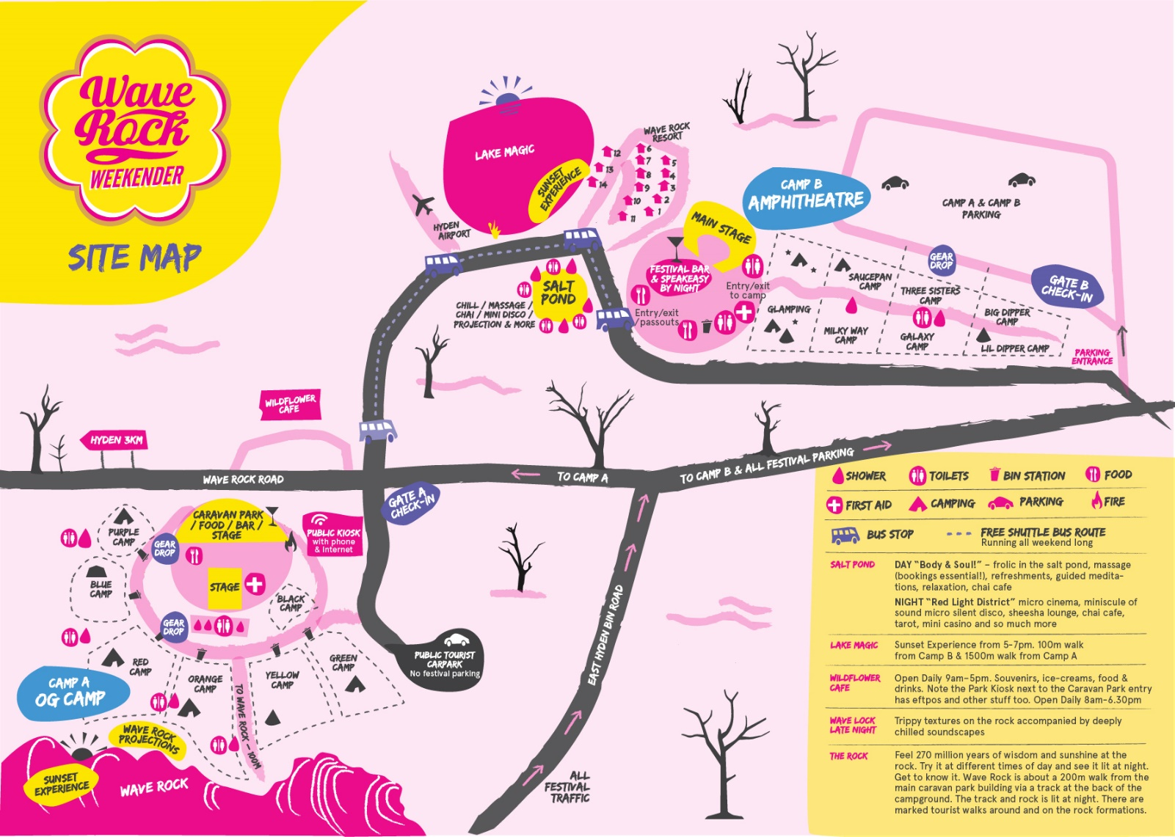
Picture of a bright coloured site map, detailing the location of two camp sites. Camp site A or OG Camp (located at the Caravan Park) and Camp site B or Amphitheatre (located at the Wave Rock Resort) Images depicting a stage an live music, camping, food, bar, shower and toilet facilities at both sites. A salt pond (located near Camp B) with showers and toilets as well as massage, chai hut and silent disco.
Lak Magic Sunset experience near Camp B (Amphitheatre Stage) area.
Wave Rock Sunset experience near Camp A (OG Camp) area.

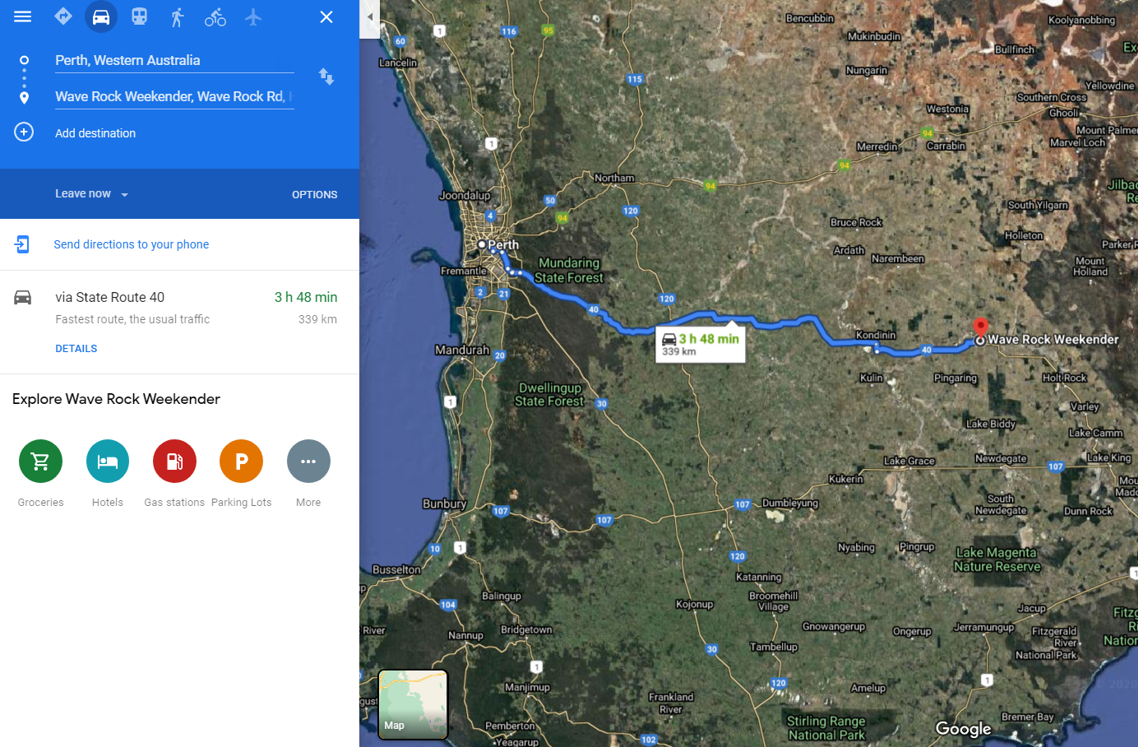
ROUTE MAP showing the driving path from Perth to Hyden, WA.
Time for drive is 3hours and 48minutes.
Distance: 339km
(allow four hours with stops to reach the event)

